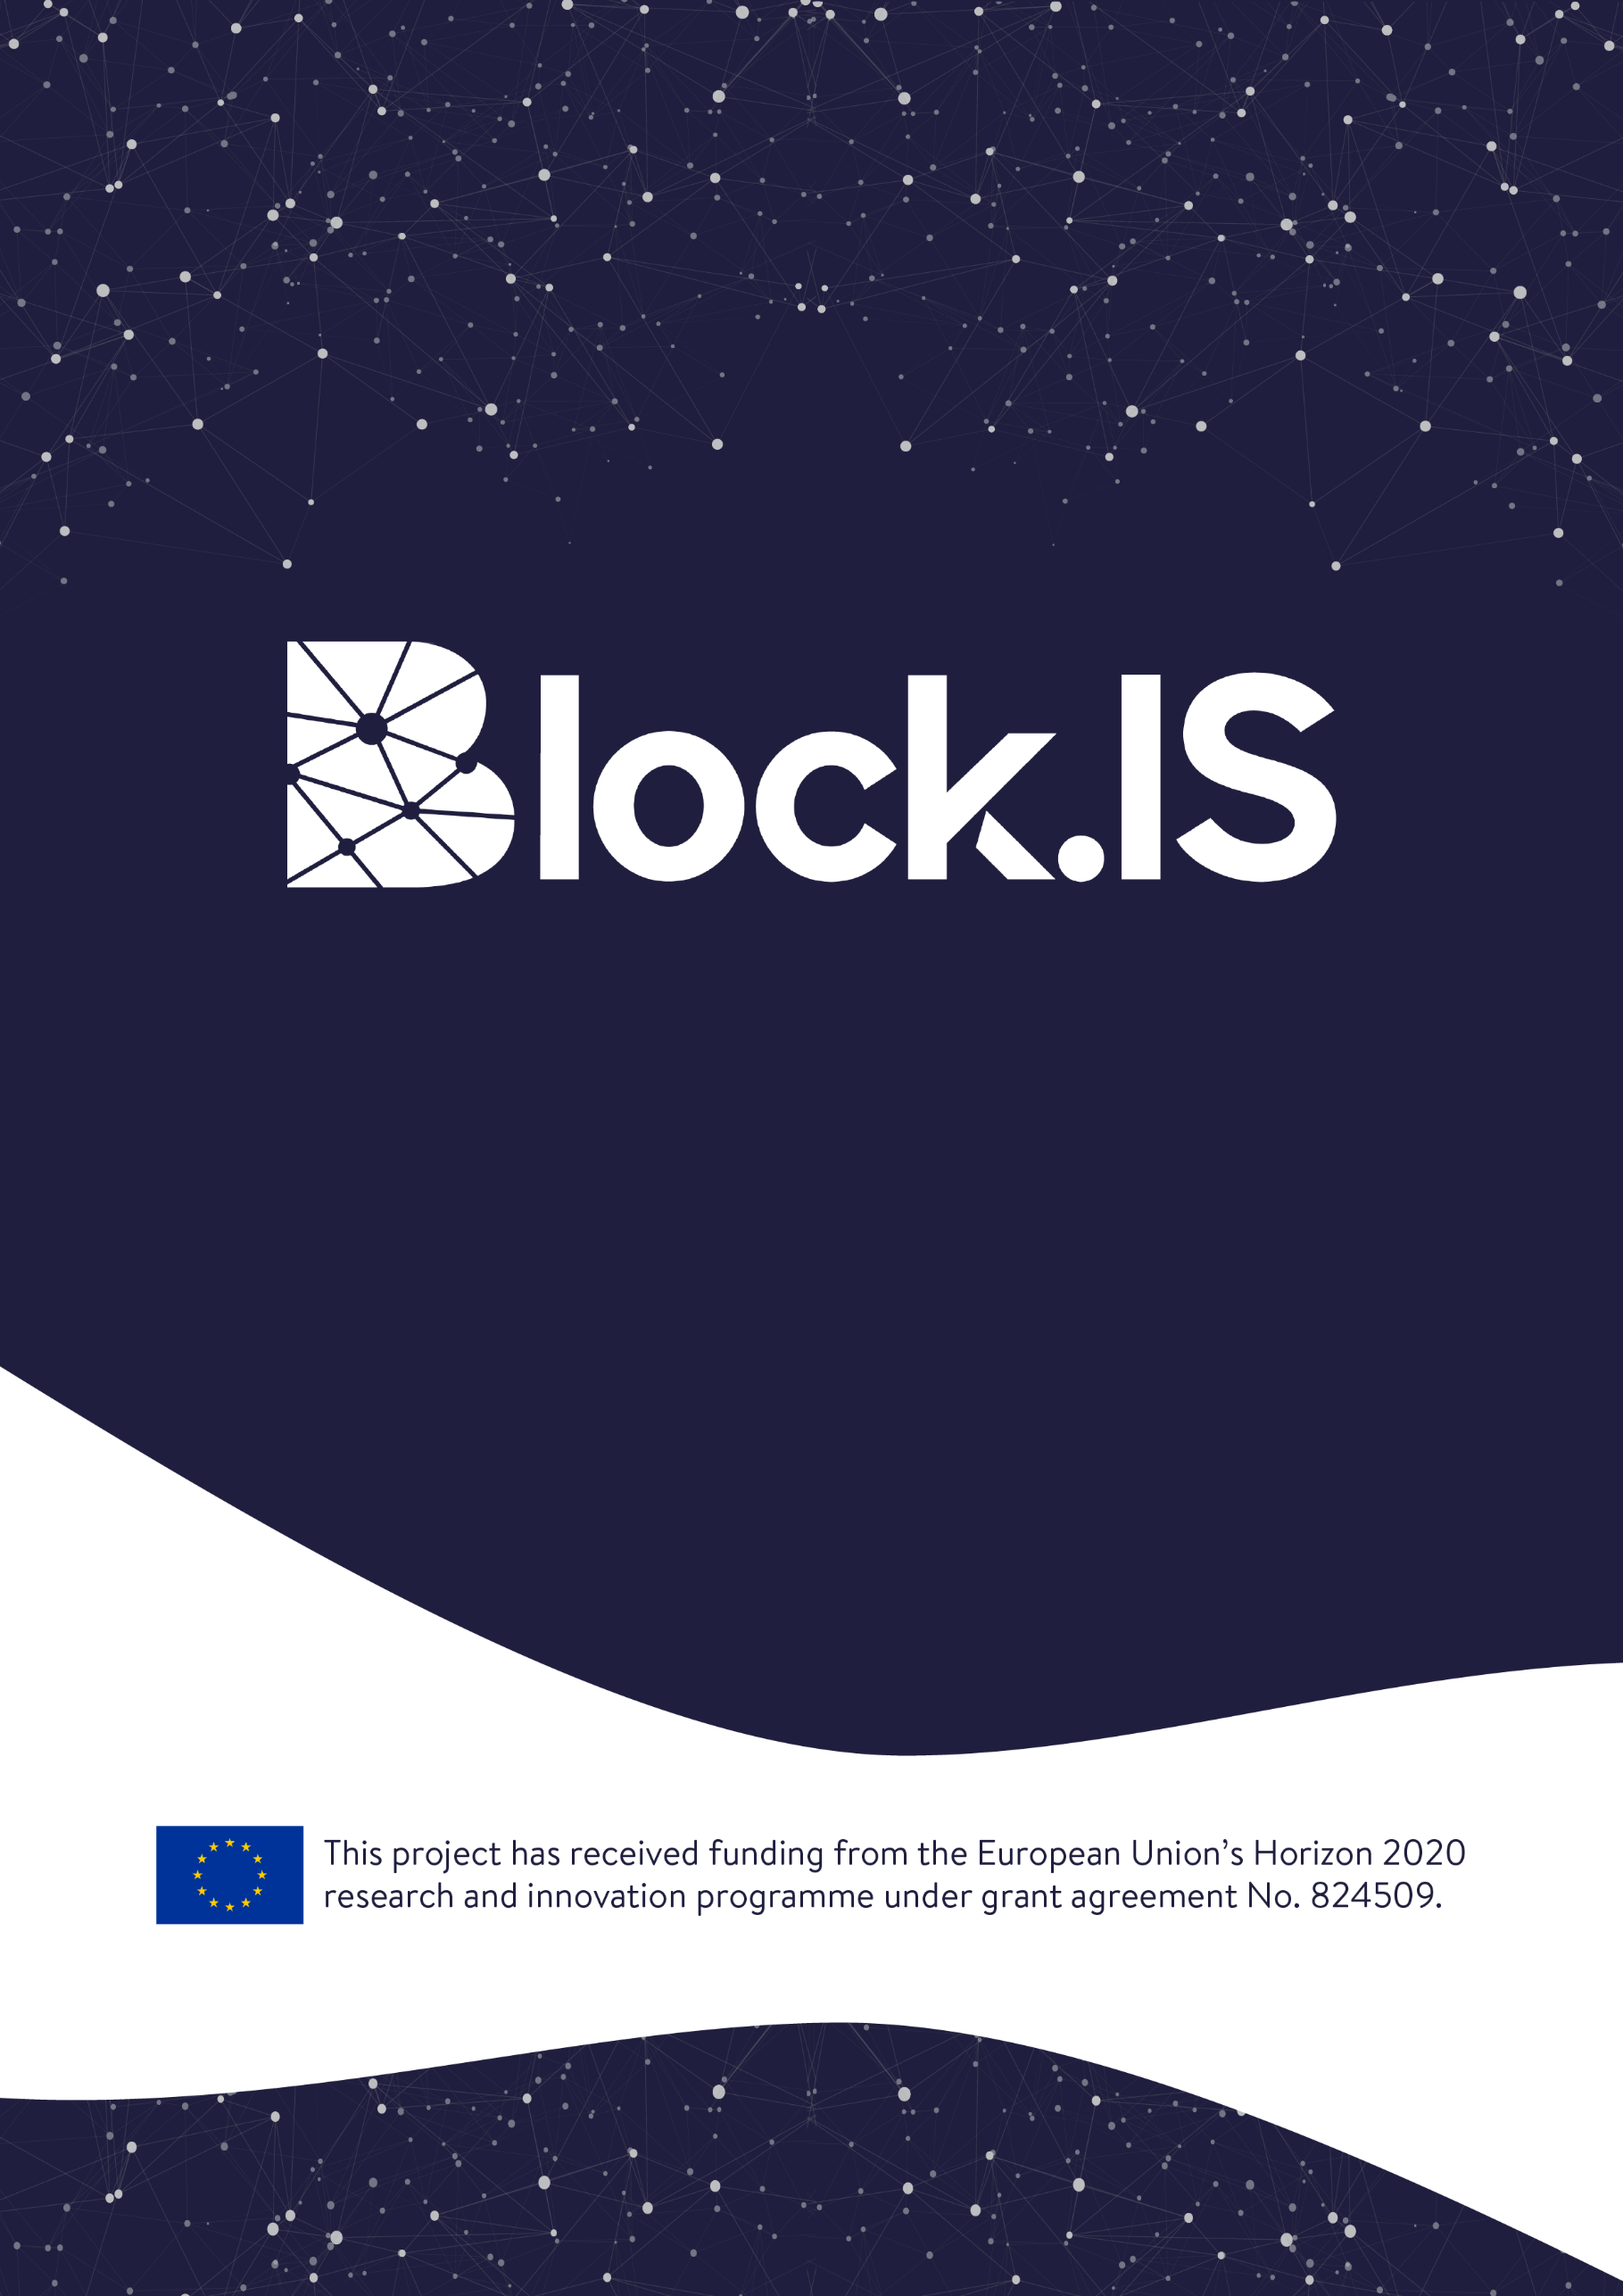
Open Call Beneficiary Agreement Agreement Number: Block.IS-OC1-2019/__
(insert the number of your position in the Rank list from your Evaluation Summary Report)

Table of contents
Contracting parties 3
General Provisions 3
Article 1 – Entry into force & Termination of the contract 4
1.1 Entry into force 4
1.2 Contract Termination 4
Article 2 – Obligations and Responsibilities of the Beneficiary 5
Article 3 – Breach of Contractual obligations 5
Article 4 – Financial contribution and financial provisions 5
4.1 Maximum financial contribution 5
4.2. Distribution of the financial contribution 5
4.3. Payments schedule 6
Article 5 – Liability of the Beneficiary 6
Article 6 – Confidentiality 7
Article 7 – Force Majeure 7
Article 8 – Information and communication 7
Article 9 – Data protection 8
9.1. Data protection obligations 8
9.2. New data produced 8
Article 10 – Financial audits and controls 8
Article 11 – Amendments 9
Article 12 – Language 9
Article 13 – Applicable Law 9
Article 14 – Settlement of disputes 9
Annexes 11

Contracting parties

F6S NETWORK LIMITED (F6S), established in KEMP HOUSE CITY ROAD 152-160, LONDON EC1V 2NX, United Kingdom, VAT number: GB166239787, represented for the purposes of signing the Agreement by CEO, Sean KANE, legal representative of F6s.
Hereinafter referred as the “Contractor”

POSLOVNO UDRUZENJE VOJVODJANSKI IKT KLASTER (VOICT), established in TRG DOSITEJA OBRADOVICA 6, NOVI SAD 21000, Serbia, VAT number: RS106621203, represented for the purposes of signing the Agreement by Mr Milan Šolaja, CEO, legal representative of VOICT.
Hereinafter referred as the “Treasurer”

Of the one part,

[COMPANY_NAME], a SME organized under the laws of [COUNTRY], established in [LEGAL_ADDRESS], with VAT number [VAT_NUMBER], duly represented by [LEGAL_REPRESENTATIVE], [LEGAL_REPRESENTATIVE_POSITION],
Hereinafter referred as the “Beneficiary”
Hereinafter collectively referred as the “Contracting Parties”

HAVE AGREED to the following terms and conditions including those in the following Annexes, which form an integral part of this BLOCK.IS Open Call 1 Beneficiary Agreement (hereinafter referred as the “Contract”):

General Provisions
The European Commission (hereinafter referred as the “EC”) and the Contractor, as a member of the Block.IS consortium, have signed the Grant Agreement no 824509 for the implementation of the project “Blockchain Innovation Spaces” (Acronym: BLOCK.IS) within the framework of the Programme H2020-INNOSUP-2018-2020/H2020-INNOSUP-2018-01.
The Beneficiary has received the favourable resolution by the external evaluators and therefore is entitled to receive funding and services according to the terms and conditions set out under this Beneficiary Agreement and in accordance with the Annex 2: Open Call Guidelines for Applicants.
This Contract aims at defining the framework of rights and obligations of the Contracting Parties.
The Funding received by the Beneficiary is property of the EC. The Contractor and Treasurers are mere holders and managers of the funds.

Article 1 – Entry into force & Termination of the contract

1.1 Entry into force
This Contract shall enter into force on the day of its signature by the last Contracting Party. The Contractor shall sign this contract, only after all of the following documents have been received from the Beneficiary:
- The original signed Declaration of Honour (as given in Annex 4 of this Contract);
- SME Declaration form (as given in Annex 5 of this Contract);
- Copy of ID-card or Passport of legal representative(s) of the SME;
- Copy of the original Extract of SME registration;
- Proof of VAT registration;
- Bank Information Form (as given in Annex 6 of this Contract).

All documents shall be sent to the Contractor first via email to the following address: administrative@blockis.eu, while the Annexes 1, 2, 3 and 3.1 of this Contract will also be sent as originals, via regular mail, to the following address:
Vojvodina ICT Cluster (BLOCK.IS Team)
Vojvodjanskih brigada 28,
21000 Novi Sad
(premises at Business Incubator Novi Sad)
Serbia
The Beneficiary is solely responsible for the accuracy of all data provided to the Contractor.

1.2 Contract Termination
- This Contract covers all three phases of Block.IS acceleration program, namely INNOVATE, EXPERIMENT and COMMERCIALISE.
- At the end of each of the aforementioned phases INNOVATE, EXPERIMENT and COMMERCIALISE, an evaluation of the Beneficiary projects’ progress will take place as fully described in Annex 2 “Guidelines for Applicants”.
- In case the Beneficiary is not selected to enter the next phase, this Contract is automatically terminated, and the Beneficiary fully accepts that no additional payments due to said next phases will be made by the Contractor.

- This Contract also terminates in the event of unjustified withdraw by the Beneficiary of the current fulfilment of its Contract obligations. “Unjustified withdraw” covers any situation out of “Force Majeure” qualification which determines the absence of performance of the Beneficiary contractual obligations. In this particular case, it entitles the Contractor the right to claim the Beneficiary the full refund of all payments made to the Beneficiary up to date.

Article 2 – Obligations and Responsibilities of the Beneficiary
The obligations and responsibilities of the Beneficiary are defined in detail in the Annex 2 ‐ Guidelines for Applicants.
Additionally, the Beneficiary shall take every necessary precaution to avoid any risk of conflict of interest relating to economic interests, political or national affinities, personal or any other interests liable to influence the impartial and objective performance of the Project. In case the Beneficiary is involved in a conflict of interest or in a risk of conflict of interest, the Beneficiary must formally notify this situation to the Contractor without delay and immediately take all the necessary steps to rectify this situation.

Article 3 – Breach of Contractual obligations
In the event of the breach of the contractual obligations by the Beneficiary, the Contractor reserves the right to claim the Beneficiary the full refund of all payments made to the Beneficiary up to date. The breach of the contractual obligations by the Beneficiary shall be determined by the BLOCK.IS Consortium or BLOCK.IS Project Coordinator. Not attending the Event (unless in the case of Force Majeure) or attending the Event in a manner which intentionally disrupts the Event, shall be deemed as breach of the contractual obligations by the Beneficiary. The provision of false or misleading declarations by the Beneficiary or any unsolved situation of conflict of interest also constitute examples of breach of contractual obligations by the Beneficiary.
For British applicants: Please be aware that eligibility criteria must be complied with for the entire duration of the grant. If the United Kingdom withdraws from the EU during the grant period without concluding an agreement with the EU ensuring in particular that British applicants continue to be eligible, you will cease to receive EU funding (while continuing, where possible, to participate) or be required to leave the project.

Article 4 – Financial contribution and financial provisions

4.1 Maximum financial contribution
The maximum financial contribution to be granted by the Contractor to the Beneficiary shall not exceed the amount of Sixty Thousand Euros (60,000€).

4.2. Distribution of the financial contribution
The financial contribution to be granted to the Beneficiary shall be calculated and distributed in accordance with the provisions of the Annex 2: Guidelines for Applicants.
In any case, the financial grant to be paid will always be subject to:
- A favourable resolution by the external evaluators and Block.IS project responsible for assessing the Project in each of the phases;
- Reception and acceptance of the relevant Financial Statement (F1, F2, F3 and F4) of the beneficiary;
- The Beneficiary Bank Account (Annex 6) matches the Financial Statement Bank Account;
- The availability of funds in TREASURER bank account during the relevant payment period
- Payments to the Beneficiary will be made by the Treasurer. In particular:
- The Treasurer reserves the right to withhold the payments in case the Beneficiary does not fulfil with its obligations and tasks as per Annex 2 ‐ Guidelines for Applicants;
- Banking and transaction costs charged by any of the banks related to the handling of any financial resources made available to the Beneficiary by the Treasurer shall be covered by the holder of the bank account which originated the cost. This means that the Treasurer bears the cost of transfers charged by its bank and the Beneficiary bears the cost of transfers charged by its bank.;
- Payments will be released no later than thirty (30) natural days after the notification by the Contractor;
- The Beneficiary is responsible for complying with any tax and legal obligations that might be attached to this financial contribution.

4.3. Payments schedule
The payment schedule is directly linked to the relevant phase of the Project as per the Guidelines for Applicants (Annex 2).
Expected date of payment | Amount  (in EUROs) | Condition / Event | Linked Phase
February  2020 | 3.000 | Subject to participating at the Block.IS INNOVATE event, submitting project presentation slides and pitching proposal idea | Phase 1: INNOVATE
April  2020 | 15.000 | Subject to successful review of Deliverable D1: Design & presentation of the idea/ prototype design during a remote evaluation | Phase 2: EXPERIMENT Design Sub-phase
October 2020 | 35.000 | Subject to successful review of Deliverables D2: Implementation & D3: Business & Exploitation Plan, participation at the Demonstration Event and demonstration of the MVP (TRL 4-6) & Pitching on the solution | Phase 2: EXPERIMENT Implementation & Validation Sub-phase
December 2020 | 7.000 | Subject to successful review of project presentation slides, participation at the Commercialization demonstration of the product (TRL 8-9) & pitching on the solution | Phase 3: COMMERCIALISE

The Beneficiary is entitled to receive exclusively those payments allocated to each specific stage of the Project provided that the conditions under Article 4.2 are met.

Article 5 – Liability of the Beneficiary
Neither the Contractor nor the EC can be held liable for any acts or omissions of the Beneficiary in relation to this Contract. At the same time, the Beneficiary is responsible for any act or omission that causes damage to the Contractor, the Data Provider, and/or the EC in relation to this Contract.
The Beneficiary shall bear sole responsibility for ensuring that their acts within the framework of this Contract do not infringe third parties’ rights. There is no joint liability between the Contracting Parties.

Article 6 – Confidentiality
With respect to all information of whatever nature or form as is disclosed between the Contracting Parties in connection with the Project and identified in writing as confidential, the terms of this Article shall apply.
The Contracting Parties agree that such information is communicated on a confidential basis and its disclosure may be prejudicial to the owner of the information.

Article 7 – Force Majeure
“Force Majeure” shall mean, any unforeseeable exceptional situation or event beyond the Contracting Parties control, which prevents either of them from fulfilling any of their obligations under the Agreement, which was not attributable to error or negligence on their part and which proves to be inevitable in spite of the exercising all due diligence.
Any default of a service, defect in equipment or material or delays in making them available, unless they stem directly from a relevant case of force majeure, as well as labour disputes, strikes or financial difficulties cannot be invoked as force majeure.
The Contracting Parties shall take the necessary measures to limit any damage due to force majeure. They shall do their best to resume the implementation of the action as soon as possible.
No Contracting Party shall be considered to be in breach of its obligations and tasks if such breach is caused by Force Majeure. A Contracting Party will notify the other Contracting Party of any Force Majeure as soon as possible. In case the Beneficiary is not able to overcome the consequences of Force Majeure within 10 (ten) days after such notification, the Contractor will decide accordingly including the termination of the Contract.

Article 8 – Information and communication
Any publicity made by the Beneficiary in respect of the project, in whatever form and on or by whatever medium, must specify that it reflects only the author’s views and that the Contractor, BLOCK.IS consortium or EC are not liable for any use that may be made of the information contained therein.
The Contractor, BLOCK.IS consortium and EC shall be authorized to publish, in whatever form and on or by whatever medium, the following information:
- the name of the Beneficiary;
- contact address of the Beneficiary;
- the general purpose of the project;
- the amount of the financial contribution of the EC.
The Beneficiary shall ensure that all necessary authorizations for such publication have been obtained and that the publication of the information by the Contractor, BLOCK.IS Consortium or EC does not infringe any rights of third parties.
Upon a duly substantiated request by the Contractor on behalf of the Beneficiary, the EC may agree to forego such publicity if disclosure of the information indicated above would risk compromising the beneficiary’s security, academic or commercial interests.

Article 9 – Data protection

9.1. Data protection obligations
The Contracting Parties have the obligation to abide by the Regulation (EU) 2016/679 (General Data Protection Regulation – GDPR) of the European Parliament and of the Council of 27 April 2016 on the protection of natural persons with regard to the processing of personal data and on the free movement of such data.
The processing of personal data shall be carried out lawfully, fairly and in a transparent manner, collected for specified purposes and adequate, relevant and limited to what is necessary in relation to the purposes for which it is processed.
The Beneficiary will use and process the data only for the purposes of this Contract and during the length of the Contract. Any unauthorised use is forbidden. In any event, neither the Contractor nor the Data Provider will be held responsible for any abusive use of data incurred into by the Beneficiary.
The Beneficiary shall not to try to re-identify anonymised data. In the event that re-identification occurs, the Beneficiary commits not to use such data.
The Beneficiary shall delete, at the end of this Contract, the data to which the Beneficiary has been granted access during the incubation process, except where an agreement is entered into with the Data Provider.

9.2. New data produced
The Beneficiary acknowledges that he/she will be the “data controller” of any new dataset of piece of personal information that the Beneficiary may produce in the course of the Block.IS project.

Article 10 – Financial audits and controls
The EC may, at any time during the implementation of the Project and up to five years after the end of the Block.IS project (foreseen for 31 December 2021), arrange for financial audits to be carried out, by external auditors, or by the EC services themselves including the European Anti‐Fraud office (OLAF), on the Beneficiary. The audit procedure shall be deemed to be initiated on the date of receipt of the relevant letter sent by the EC. Such audits may cover financial, systemic and other aspects (such as accounting and management principles) relating to the proper execution of the Grant Agreement. They shall be carried out on a confidential basis.
The Beneficiary shall make available directly to the EC all detailed information and data that may be requested by the EC or any representative authorised by it, with a view to verifying that the Grant Agreement is properly managed and performed in accordance with its provisions and that costs have been charged in compliance with it. This information and data must be precise, complete and effective.
The Beneficiary shall keep the originals or, in exceptional cases, duly authenticated copies – including electronic copies ‐ of all documents relating to the Contract until 2026. These shall be made available to the EC where requested during any audit under the Grant Agreement.
In order to carry out these audits, the Beneficiary shall ensure that the EC´s services and any external body(ies) authorised by it have on‐the‐spot access at all reasonable times, notably to the Beneficiary’s offices, to its computer data, to its accounting data and to all the information needed to carry out those audits, including information on individual salaries of persons involved in the project. They shall ensure that the information is readily available on the spot at the moment of the audit and, if so requested, that data be handed over in an appropriate form.
On the basis of the findings made during the financial audit, a provisional report shall be drawn up. It shall be sent by the EC or its authorised representative to the beneficiary concerned, which may make observations thereon within one month of receiving it. The EC may decide not to take into account observations conveyed or documents sent after that deadline. The final report shall be sent to the beneficiary concerned within two months of expiry of the aforesaid deadline.
On the basis of the conclusions of the audit, the EC shall take all appropriate measures which it considers necessary, including the issuing of recovery orders regarding all or part of the payments made by it and the application of any applicable sanction.
The European Court of Auditors shall have the same rights as the EC, notably right of access, for the purpose of checks and audits, without prejudice to its own rules. In addition, the EC may carry out on‐the‐spot checks and inspections in accordance with Council Regulation (Euratom, EC) No 2185/96 of 11 November 1996 concerning on‐the‐spot checks and inspections carried out by the EC in order to protect the European Communities’ financial interests against fraud and other irregularities.

Article 11 – Amendments
Amendments or changes to this Contract shall be made in writing and signed by the duly authorized representative of the Contracting Parties. Nevertheless, In the event the EC modifies the conditions, the Contractor will amend the Contract accordingly.

Article 12 – Language
This contract is drawn up in English, language which shall govern all documents, notices, meetings and processes relative thereto.

Article 13 – Applicable Law
This Contract shall be construed in accordance with and governed by the laws of Belgium.

Article 14 – Settlement of disputes
If the Contracting Parties are unable to resolve a dispute amicably, such dispute will be finally settled under the Rules of Arbitration of the International Chamber of Commerce by three (3) arbitrators in Brussels.
Each of the Contracting Parties to the dispute shall appoint one (1) arbitrator and the three (3) arbitrators so appointed shall elect the presiding arbitrator. Should a Party to the dispute which should appoint an arbitrator fails to do so within fourteen (14) days of the delivery of the written notice to do so from the other Party to the dispute or should the appointed arbitrators fail to reach agreement on the presiding arbitrator within fourteen (14) days after their appointment, such arbitrator shall be appointed in accordance with the Rules upon request of any of the Parties to the dispute.
The seat of arbitration shall be Brussels.
The Contracting Parties agree that the language of the arbitration, including oral hearings, written evidence and correspondence, shall be English.
A duly rendered arbitration award shall be final and binding on the Contracting Parties to the dispute. Each Contracting Party to the arbitration conducted in accordance with this section hereof shall bear its own expenses incurred in connection with such arbitration, including fees of its legal counsels. All other costs and expenses shall be apportioned between the Contracting Parties to the arbitration in accordance with the decision of the arbitrators.
Nothing in this Contract shall limit the Contracting Parties right to seek injunctive relief or to enforce an arbitration award in any applicable competent court of law.
AS WITNESS:
The Contracting Parties have caused this Contract to be duly signed by the undersigned authorized representatives in three (3) copies:
For F6S (the Contractor)  Mr/Ms Sean Kane  CEO  Signature  Done at XXXXXXX__________ on DD/MM/201Y | For VOICT (Treasurer), established in TRG DOSITEJA OBRADOVICA 6, 21000 NOVI SAD, SERBIA  Mr Milan Šolaja,  CEO  Signature  Done at Novi Sad on _____________________
For [SME/Individual Entrepreneur_NAME] (the Beneficiary)
Mr/Ms [NAME SURNAME]
[POSITION_IN_COMPANY]
Signature

Done at __________ on DD/MM/201Y

Annexes

