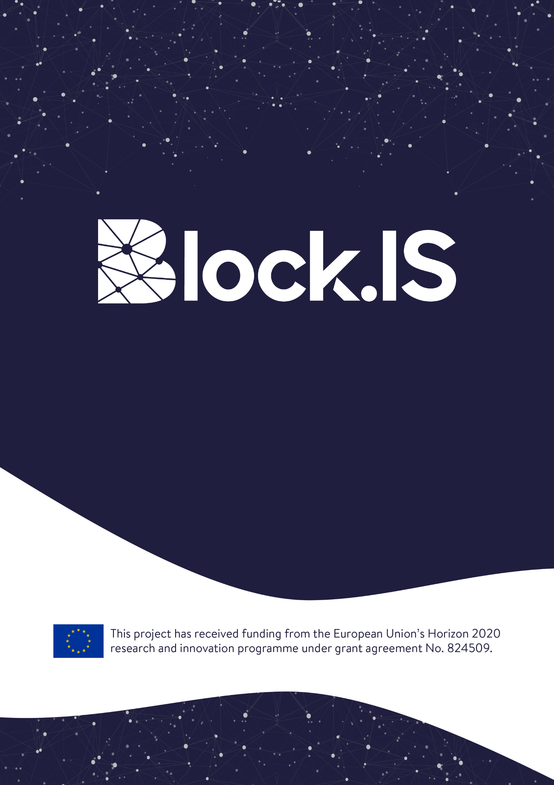
Annex 6
Sub Grant Travel Agreement No:XXX
September/2019
Table of contents
Contracting parties 3
General Provisions 3
Article 1 – Entry into force of the contract 3
Article 2 – Obligations and Responsibilities of the Beneficiary 4
Article 3 – Breach of Contractual obligations 4
Article 4 – Financial contribution and financial provisions 4
Article 5 – Liability of the Beneficiary 4
Article 6 – Confidentiality 5
Article 7 - Force Majeure 5
Article 8 - Information and communication 5
Article 9 – Language 6
Article 10 – Applicable Law 6
Article 11 – Settlement of disputes 6

Contracting parties

F6S NETWORK LIMITED (F6S), established in KEMP HOUSE CITY ROAD 152-160, LONDON EC1V 2NX, United Kingdom, VAT number: GB166239787, represented for the purposes of signing the Agreement by CEO, Sean KANE, legal representative of F6S, hereinafter referred as the “Contractor”
POSLOVNO UDRUZENJE VOJVODJANSKI IKT KLASTER (VOICT), established in TRG DOSITEJA OBRADOVICA 6, NOVI SAD 21000, Serbia, VAT number: RS106621203, represented for the purposes of signing the Agreement by Mr Milan Šolaja, CEO, legal representative of VOICT, hereinafter referred as the “Treasurer”
Of the one part,
[ENTITY_NAME], a SME/Cluster organization organized under the laws of [COUNTRY], established in [LEGAL_ADDRESS], with VAT number [VAT_NUMBER], duly represented by [LEGAL_REPRESENTATIVE], [LEGAL_REPRESENTATIVE_POSITION], hereinafter referred as the “Beneficiary”
Hereinafter collectively referred as the “Contracting Parties”
HAVE AGREED to the following terms and conditions which form an integral part of this Block.IS Travel Grant Agreement (hereinafter referred as the “Contract”)

General Provisions
The European Commission (hereinafter referred as the “EC”) and the Contractor, as a member of the consortium, have signed the Grant Agreement no 824509 for the implementation of the project “Blockchain Innovation Spaces” (Acronym: Block.IS) within the framework of the Programme H2020-INNOSUP-2018-01-two-stage.
According to the abovementioned Grant Agreement, project Block.IS is organizing its first Block.IS Cluster Mission event, which will take place on 27th-28th September 2019.
The Block.IS team has invited clusters and SMEs, coming from all participating H2020 countries, to participate in the event.
The Beneficiary has been selected in the Block.IS Open call and therefore is entitled to receive ________ euros as a Travel Grant that will cover his/her travel costs to attend the Event.
This Contract aims at defining the framework of rights and obligations of the Contracting Parties.
The Funding received by the Beneficiary is owned by the EC. The Contractor is a mere holder and manager of the funds.

Article 1 – Entry into force of the contract
This Contract shall enter into force on the day of its signature by the last Contracting Party.
The Contractor shall sign this contract, only after all of the following documents have been received from the Beneficiary:
- Declaration of Honour of the Beneficiary
- Copy of ID-card or Passport of natural person or legal representative of the entity
- Bank Account Information Form
- Request for Payment

Article 2 – Obligations and Responsibilities of the Beneficiary
The obligations and responsibilities of Beneficiary are to travel to the Event, and to participate in Block.IS Cluster Mission in an appropriate manner. Appropriate manner means that the participant will comply with the house rules in case of an onsite meeting and in general to the meeting rules.
The Beneficiary shall take every necessary precaution to avoid any risk of conflict of interest relating to economic interests, political or national affinities, family or emotional ties or any other interests liable to influence the impartial and objective performance of the project.

Article 3 – Breach of Contractual obligations
In the event of the breach of the contractual obligations by the Beneficiary, the Contractor may request the Beneficiary to refund in the totality of all payments made to the Beneficiary. The breach of the contractual obligations by the Beneficiary shall be determined by the Block.IS Consortium or Block.IS Project Coordinator. Not attending the Event (unless in the case of Force Majeure, as set in Article 7) or attending the Event in a manner which intentionally disrupts the Event, shall be deemed as breach of the contractual obligations by the Beneficiary.

Article 4 – Financial contribution and financial provisions
Under this Contract, the Beneficiary is granted the direct financial support of ________ EUR (_______________ euros) to cover a part of Beneficiary’s travel costs and costs of stay to participate at the Event.
The Funding will be granted according to the distance from the place of origin of the person to the city hosting the event in a straight line. For that purpose, shall be used the distance calculator tool made available by the EC for the Erasmus+ Programme. No proofs of the cost of travel or cost of stay will be asked for.
The Funding will be released by the Contractor to the Beneficiary after all of the following conditions have been met:
- The Beneficiary has attended the Event;
- The Beneficiary has sent the documents mentioned in article 1.

- The Beneficiary is solely responsible for the accuracy of all data provided to the Contractor.

Banking and transaction costs related to the handling of Funding shall be covered by the Beneficiary and deducted from the Funding.

Article 5 – Liability of the Beneficiary
The Contractor cannot be held liable for any acts or omissions of the Beneficiary in relation to this Contract.
The Beneficiary shall bear sole responsibility for ensuring that their acts within the framework of this Contract do not infringe third parties’ rights.

Article 6 – Confidentiality
With respect to all information of whatever nature or form as is disclosed between the Contracting Parties in connection with the Project and identified in writing as confidential, the terms of this Article shall apply.
The Contracting Parties agree that such information is communicated on a confidential basis and its disclosure may be prejudicial to the owner of the information.

Article 7 - Force Majeure
“Force Majeure” shall mean, any unforeseeable exceptional situation or event beyond the Contracting Parties control, which prevents either of them from fulfilling any of their obligations under the Agreement, which was not attributable to error or negligence on their part and which proves to be inevitable in spite of the exercising all due diligence. Any default of a service, defect in equipment or material or delays in making them available, unless they stem directly from a relevant case of force majeure, as well as labor disputes, strikes or financial difficulties cannot be invoked as force majeure.
The Contracting Parties shall take the necessary measures to limit any damage due to force majeure. They shall do their best to resume the implementation of the action as soon as possible.
No Contracting Party shall be considered to be in breach of its obligations and tasks if such breach is caused by Force Majeure. A Contracting Party will notify the other Contracting Party of any Force Majeure as soon as possible. In case the Beneficiary is not able to overcome the consequences of Force Majeure within 10 (ten) days after such notification, the Contractor will decide accordingly including the termination of the Contract.

Article 8 - Information and communication
The Beneficiary must promote the sub-project, the Block.IS project and its results, by providing targeted information to multiple audiences (including the media and the public) in a strategic and effective manner and to highlight the financial support of the EC.
Unless the European Commission or the Block.IS coordinator requests or agrees otherwise or unless it is impossible, any communication activity related to the action (including in electronic form, via social media, etc.), any publicity, including at a conference or seminar or any type of information or promotional material (brochure, leaflet, poster, presentation etc.), and any infrastructure, equipment and major results funded by the grant must:
(a) display the EU emblem;
(b) display the Block.IS logo and
(c) include the following text:
For communication activities: “This project has indirectly received funding from the European Union’s Horizon 2020 research and innovation programme under project Block.IS (grant agreement No 824509)”.
Any publicity made by the Beneficiary in respect of the project, in whatever form and on or by whatever medium, must specify that it reflects only the author’s views and that the Contractor, Block.IS consortium or EC are not liable for any use that may be made of the information contained therein.
The EC and the Block.IS consortium shall be authorised to publish, in whatever form and on or by whatever medium, the following information:
- the name of the beneficiary;
- contact address of the beneficiary;
- the general purpose of the project;
- the amount of the financial contribution foreseen for the project; after the final payment, and the amount of the financial contribution actually received;
- the geographic location of the activities carried out;
- the list of dissemination activities and/or of patent (applications) relating to foreground;
- the details/references and the abstracts of scientific publications relating to foreground and, if funded within the sub-project, the published version or the final manuscript accepted for publication;
- the publishable reports submitted to Block.IS;
- any picture or any audio-visual or web material provided to the EC and Block.IS in the framework of the project.

The Beneficiary shall ensure that all necessary authorizations for such publication have been obtained and that the publication of the information by the Contractor, Block.IS Consortium or EC does not infringe any rights of third parties.
Upon a duly substantiated request by the Contractor on behalf of the Beneficiary, the EC may agree to forego such publicity if disclosure of the information indicated above would risk compromising the beneficiary’s security, academic or commercial interests.

Article 9 – Language
This contract is drawn up in English, language which shall govern all documents, notices, meetings and processes relative thereto.

Article 10 – Applicable Law
This Contract shall be construed in accordance with and governed by the laws of Belgium.

Article 11 – Settlement of disputes
If the Contracting Parties are unable to resolve a dispute amicably, such dispute will be finally settled under the Rules of Arbitration of the International Chamber of Commerce by three (3) arbitrators in Brussels.
Each of the Contracting Parties to the dispute shall appoint one (1) arbitrator and the two (2) arbitrators so appointed shall elect the presiding arbitrator. Should a Party to the dispute which should appoint an arbitrator fails to do so within fourteen (14) days of the delivery of the written notice to do so from the other Party to the dispute or should the appointed arbitrators fail to reach agreement on the presiding arbitrator within fourteen (14) days after their appointment, such arbitrator shall be appointed in accordance with the Rules upon request of any of the Parties to the dispute.
The seat of arbitration shall be Brussels.
The Contracting Parties agree that the language of the arbitration, including oral hearings, written evidence and correspondence, shall be English.
A duly rendered arbitration award shall be final and binding on the Contracting Parties to the dispute. Each Contracting Party to the arbitration conducted in accordance with this section hereof shall bear its own expenses incurred in connection with such arbitration, including fees of its legal counsels. All other costs and expenses shall be apportioned between the Contracting Parties to the arbitration in accordance with the decision of the arbitrators.
Nothing in this Contract shall limit the Contracting Parties right to seek injunctive relief or to enforce an arbitration award in any applicable competent court of law.
AS WITNESS:
The Contracting Parties have caused this Contract to be duly signed by the undersigned authorized representatives in three (3) copies:
For [Entity] (the Beneficiary)  Mr/Ms [NAME SURNAME]  [POSITION_IN_COMPANY] if applicable  Signature  Done at __________ on DD/MM/2019 | For Vojvodina ICt Cluster  Mr Milan Solaja  CEO  Signature  Done at Novi Sad on 27.09.2019 | For F6S  Mr. Sean Kane  CEO  Signature  Done at London on ___________

