Proposal Title
Proposal Acronym
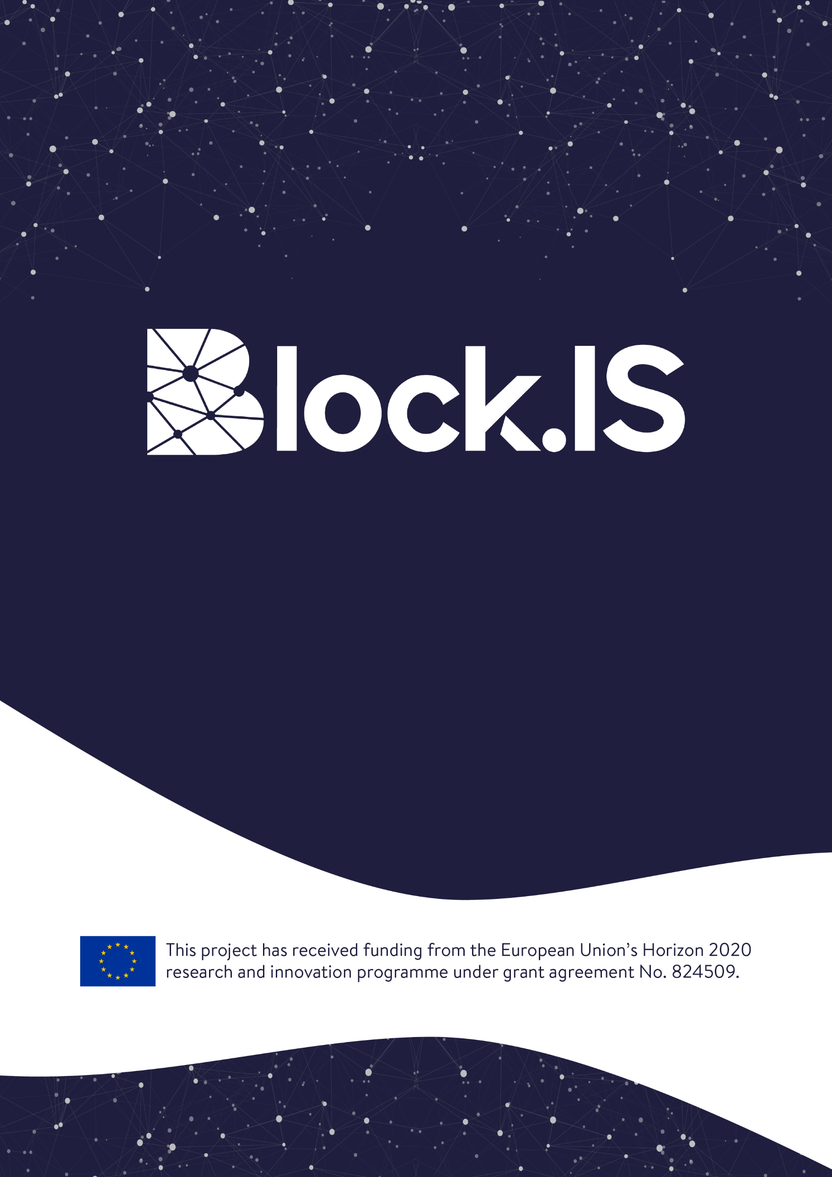
Annex 3.1: Proposal Supplement
August/2019
Table of contents
1 Project Activities Breakdown & Scheduling 3
2 Annex: Ethical/Security Checklist 4
2.1 Ethics 5
2.2 Security 5

Project Activities Breakdown & Scheduling
Describe the activities that will take place in your project from the technical point of view. Break down your work to work packages and tasks and provide timing of the different activities and components (e.g. Gantt chart or similar);
This section should answer the question “how are we going to implement the project to reach the defined objectives?”
The allowed font type is “Arial” and the minimum font size is 11 points, the paragraph spacing 6pt and the line spacing single. The page size is A4, and all margins (top, bottom, left and right) should be at least 15 mm (not including any footers or headers).
This section (after removing this explanatory text) should not be more than 1 page.

Annex: Ethical/Security Checklist
ETHICAL ISSUES TABLE
 | YES
Informed Consent
- Does the proposal involve children?
- Does the proposal involve patients or persons not able to give consent?
- Does the proposal involve adult healthy volunteers?
- Does the proposal involve Human Genetic Material?
- Does the proposal involve Human biological samples?
- Does the proposal involve Human data collection?
Research on Human embryo/foetus
- Does the proposal involve Human Embryos?
- Does the proposal involve Human Foetal Tissue / Cells?
- Does the proposal involve Human Embryonic Stem Cells?
Privacy
- Does the proposal involve processing of genetic information or personal data (e.g. health, sexual lifestyle, ethnicity, political opinion, religious or philosophical conviction)
- Does the proposal involve tracking the location or observation of people?
Research on Animals
- Does the proposal involve research on animals?
- Are those animals transgenic small laboratory animals?
- Are those animals transgenic farm animals?
- Are those animals cloned farm animals?
- Are those animals nonhuman primates?
Research Involving Developing Countries
- Use of local resources (genetic, animal, plant etc)
- Benefit to local community (capacity building i.e. access to healthcare, education etc)
Dual Use
- Research having direct military application
- Research having the potential for terrorist abuse
ICT Implants
- Does the proposal involve clinical trials of ICT implants?
I CONFIRM THAT NONE OF THE ABOVE ISSUES APPLY TO MY PROPOSAL | YES/NO

Ethics
If you have entered any ethics issues in the ethical issue table, you must:
- submit an ethics self-assessment, which:
- describes how the proposal meets the national legal and ethical requirements of the country or countries where the tasks raising ethical issues are to be carried out;
- explains in detail how you intend to address the issues in the ethical issues table, in particular as regards:
- research objectives (e.g. study of vulnerable populations, dual use, etc.)
- research methodology (e.g. clinical trials, involvement of children and related consent procedures, protection of any data collected, etc.)
- the potential impact of the research (e.g. dual use issues, environmental damage, stigmatization of particular social groups, political or financial retaliation, benefit-sharing, malevolent use, etc.).
- provide the documents that you need under national law (if you already have them), e.g.:
- an ethics committee opinion;
- the document notifying activities raising ethical issues or authorizing such activities
If these documents are not in English, you must also submit an English summary of them (containing, if available, the conclusions of the committee or authority concerned).
If you plan to request these documents specifically for the project you are proposing, your request must contain an explicit reference to the project title.

Security
Please indicate if your project will involve:
- Activities or results raising security issues: (YES/NO)
- 'EU-classified information' as background or results: (YES/NO)
- Any potential “dual use” of results: (YES/NO)

